SQL Basics
Q1. Create a New Database and Table for Employees
Task: Create a new database named company_db and Create a table named employees with the following columns:

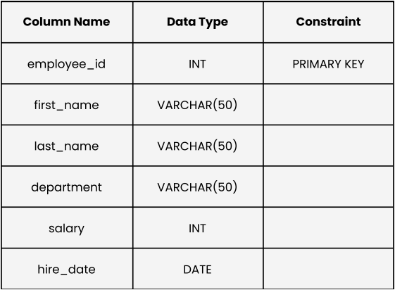

Solution : -
create database company_db;
use company_db;
create table employees(employee_id int, first_name varchar(50), last_name varchar (50), department varchar(50), salary int, hire_date date);

Q2. Insert Data into Employees Table
Task: Insert the following sample records into the employees table.

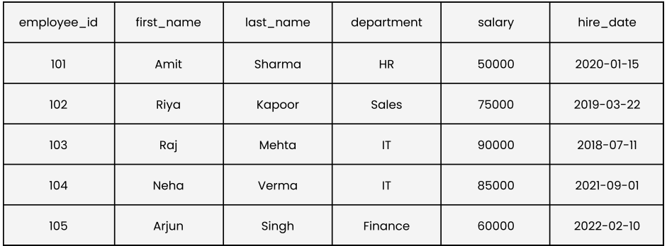
Solution : -
insert into employees (employee_id, first_name,last_name,department,salary,hire_date) values (101,'Amit','Sharma','HR',50000,'2020-01-15'), (102,'Riya','Kapoor','Sales',75000,'2019-03-22'),
(103,'Raj','Mehta','IT',90000,'2018-07-11'),(104,'Neha','Verma','IT',85000,'2021-09-01'),(105,'Arjun','Singh','Finance',60000,'2022-02-10');

Q3. Display All Employee Records Sorted by Salary (Lowest to Highest)
Hint: Use the ORDER BY clause on the salary column.
Solution : -
select * FROM employees order by SALARY asc;

Below is the result :


Q4. Show Employees Sorted by Department (A–Z) and Salary (High → Low)
Solution : -
select * from employees order by department asc, salary desc;
Below is the result :


Q5. List All Employees in the IT Department, Ordered by Hire Date (Newest First)
Solution : -
select * from employees where department = 'IT' order by hire_date desc;

Below is the result :
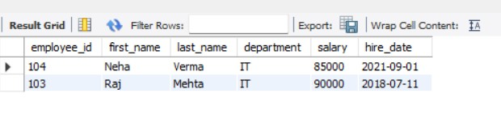

Q6. Create and Populate a Sales Table
Task: Create a table sales to track sales data.
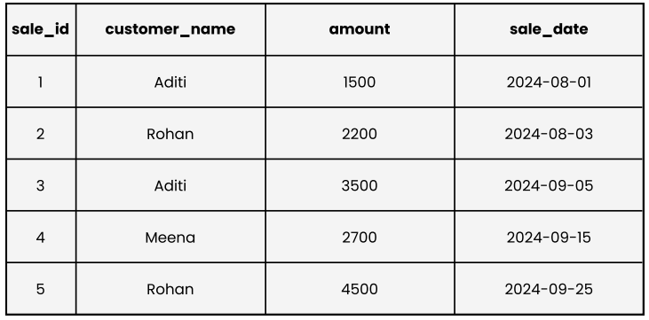
Solution : -
create table sales(sale_id int, customer_name varchar(50),amount int,sale_date date);
insert into sales(sale_id,customer_name,amount,sale_date) values (1,'Aditi',1500,'2024-08-01'),(2,'Rohan',2200,'2024-08-03'), (3,'Aditi',3500,'2024-09-05'),
(4,'Meena',2700,'2024-09-15'), (5,'Rohan',4500,'2024-09-25');

Q7. Display All Sales Records Sorted by Amount (Highest → Lowest)
Hint: Use ORDER BY amount DESC.
Solution : -
select * from sales order by Amount desc;
Below is the result :


Q8. Show All Sales Made by Customer “Aditi”
Hint: Use WHERE customer_name = 'Aditi'.
Solution : -
select * from sales where customer_name = 'Aditi';
Below is the result :


Q9. What is the Difference Between a Primary Key and a Foreign Key?
Ans :-
A Primary Key is a field (or combination of fields) in a table that uniquely identifies each record in that table. It ensures that no two rows have the same value in the primary key column and that the value cannot be NULL. The primary key helps maintain entity integrity by ensuring every record is uniquely distinguishable.
A Foreign Key is a field (or combination of fields) in one table that refers to the primary key of another table. It is used to establish and enforce a relationship between two tables. The foreign key ensures referential integrity by allowing only those values that exist in the referenced primary key, or NULL values (if allowed).
Key Differences:
- The primary key uniquely identifies records within the same table, whereas the foreign key links records between two different tables.
- A table can have only one primary key, but it can have multiple foreign keys.
- Primary key values cannot be NULL or duplicate, while foreign key values can be duplicated and may be NULL (depending on constraints).
- The primary key enforces uniqueness, while the foreign key enforces relationships between tables.
Q10. What Are Constraints in SQL and Why Are They Used?
Ans :-
Constraints are rules applied to table columns in SQL to control the type and quality of data that can be stored in a database. They help maintain data accuracy, consistency, and integrity.

Constraints are used to:
- Prevent invalid data from being inserted
- Maintain data integrity
- Enforce business rules
- Ensure relationships between tables are valid
- Reduce errors at the database level

